**Lab Exercise 7- Arduino circuit with and Code for RGB LED**

An RGB (Red-Green-Blue) LED can produce a wide variety of colors by mixing different intensities of red, green, and blue light. You’ll learn to create a basic Arduino RGB LED circuit and cycle through some basic colors as an example.

**Requirements:**

* Arduino Uno
* Breadboard (and some breadboard wires)
* 3 x Resistor (220 Ω)
* RGB LED

There are two types of RGB LEDs: *Common Anode* and *Common Cathod*e. We’ll provide example schematics and code for both types below.

**How To Connect an RGB LED to an Arduino**

Here’s the schematic for the circuit. This diagram uses three resistors and a *common anode* RGB LED (you’ll find the schematics for a *common cathode* below).

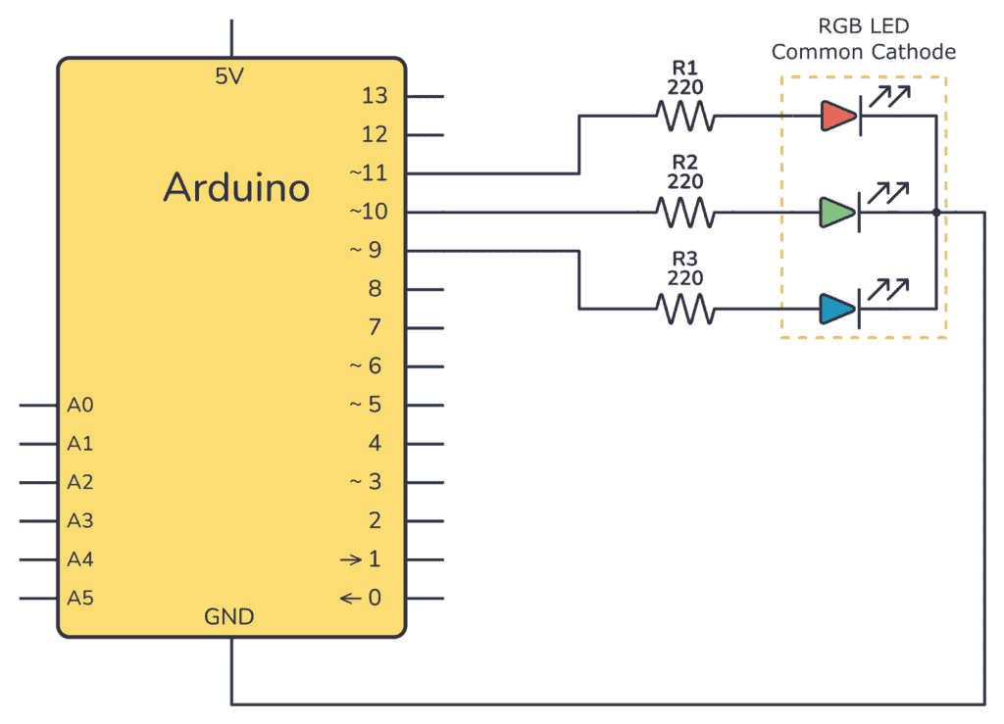

Use the breadboard images below as a visual guide to set up your connections:

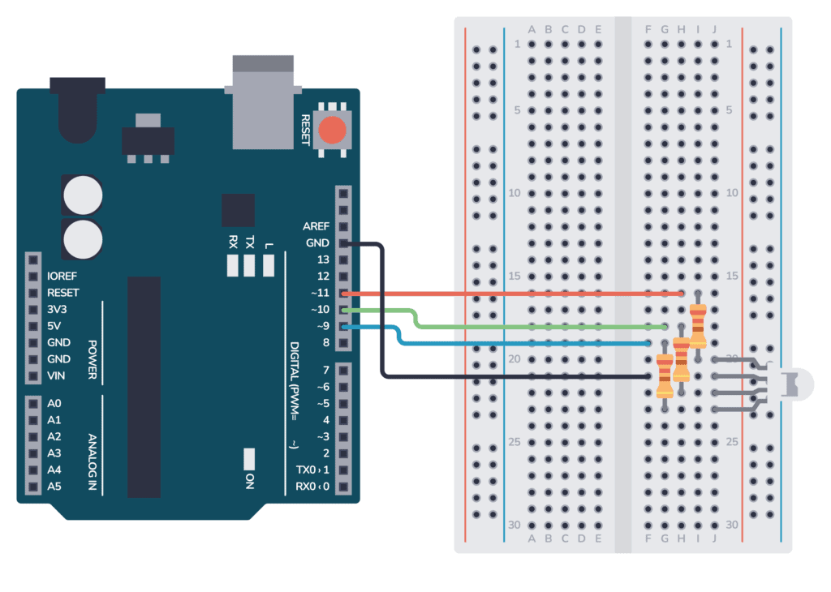

**Upload the Arduino RGB LED Code**

Upload the code below to your Arduino using the Arduino IDE, and you should see the LED cycle through different colors, stopping for one second on each color.

**Complete Arduino code for RGB LED:**

Bottom of Form

int redPin= 11;

int greenPin = 10;

int bluePin = 9;

void setup() {

pinMode(redPin, OUTPUT);

pinMode(greenPin, OUTPUT);

pinMode(bluePin, OUTPUT);

}

void loop() {

setColor(255, 0, 0); // Red Color

delay(1000);

setColor(0, 255, 0); // Green Color

delay(1000);

setColor(0, 0, 255); // Blue Color

delay(1000);

setColor(255, 255, 0); // Yellow Color

delay(1000);

setColor(0, 255, 255); // Cyan Color

delay(1000);

setColor(255, 0, 255); // Magenta Color

delay(1000);

setColor(255, 165, 0); // Orange Color

delay(1000);

setColor(128, 0, 128); // Purple Color

delay(1000);

setColor(255, 255, 255); // White Color

delay(1000);

}

void setColor(int redValue, int greenValue, int blueValue) {

analogWrite(redPin, redValue);

analogWrite(greenPin, greenValue);

analogWrite(bluePin, blueValue);

}

**Simulation:**

